6373793

Logging using SLF4J

Exercise 1: Logging Error Messages and Warning Levels

Task: Write a Java application that demonstrates logging error messages and warning levels using SLF4J.

Code:

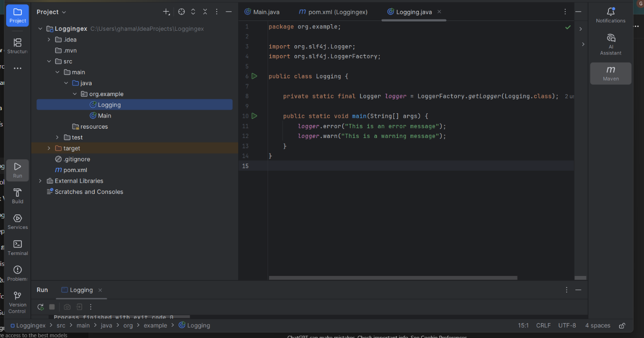

Output:

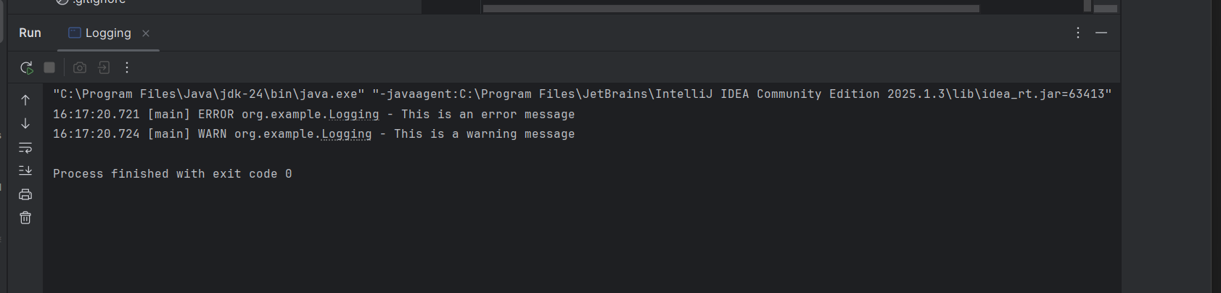

Exercise 2: Parameterized Logging

Task: Write a Java application that demonstrates parameterized logging using SLF4J.

Code:

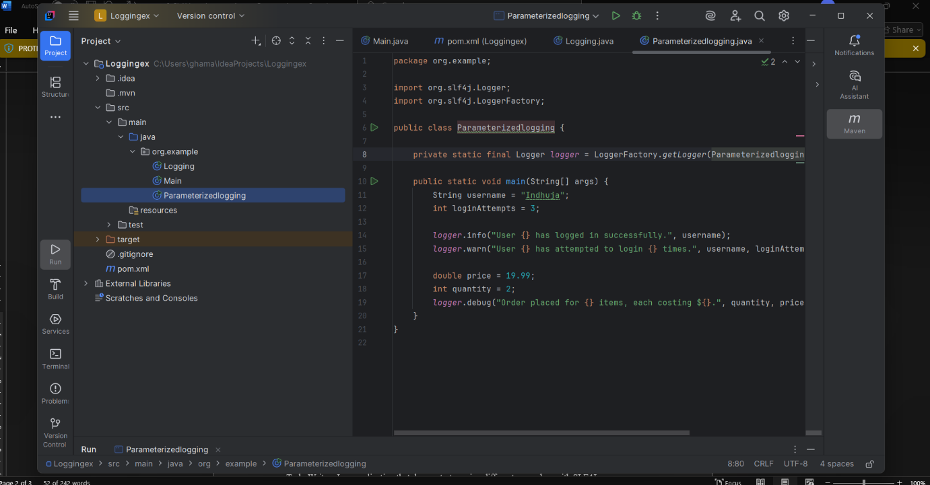

Output:

